Exercise 4 Unit 1

* Before making the snapshot, I have made a new file call File 1

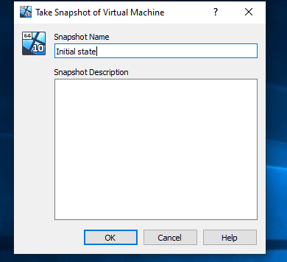

* Then we create another file called File2, and like we did before we take another snapshot called State 2.

We repeat the process creating a new file called File 2.1 an taking another snapshot called State 2.1

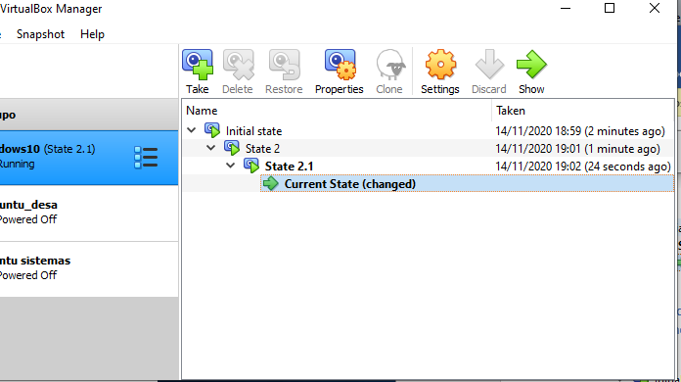

* We create a new file File2.2 and add the snapshot correspondent
* After this we close the virtual machine an restore State 2

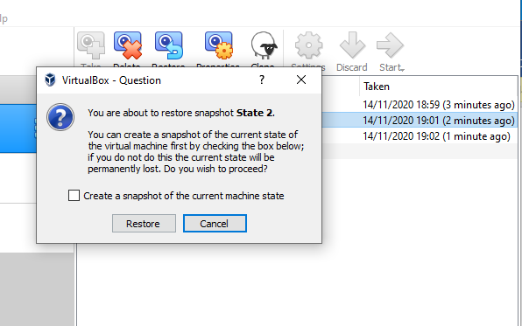

* We run the machine again and we’ll see there are less files
* Then we create a new file called File2.2 and add the snapshot
* Now, I delete State 2.1

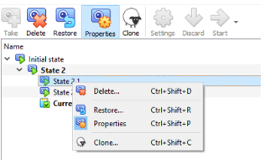

* After this step we can see the files created in State 2.1 has totally disappeared
* Next step is restoring State2.2

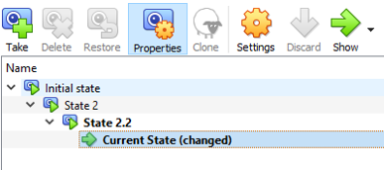

* If we delete State 2.2 the file created in this is not delete

